1.Host a Ubuntu Virtual Machine using Oracle VM Virtual Box.:-

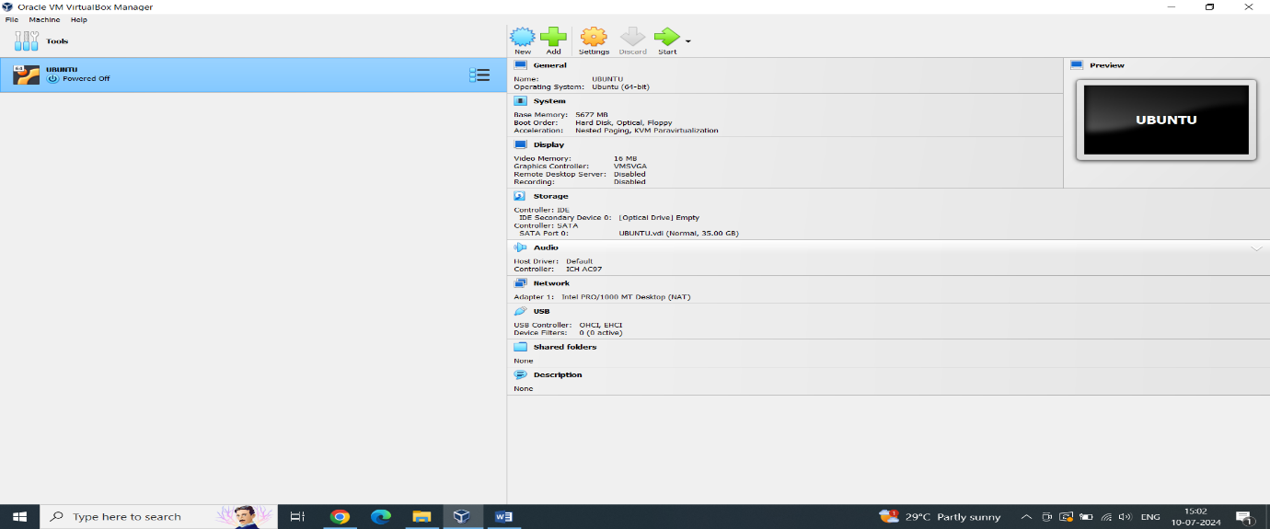

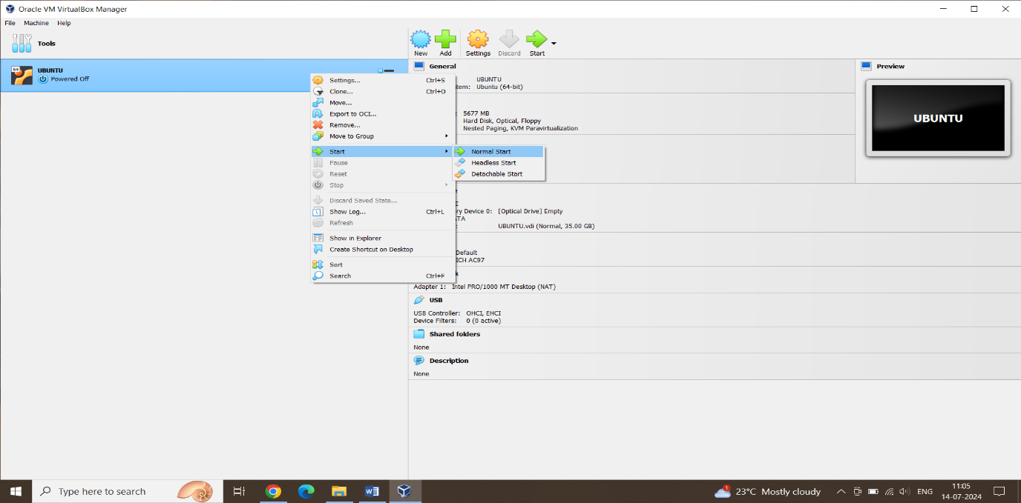

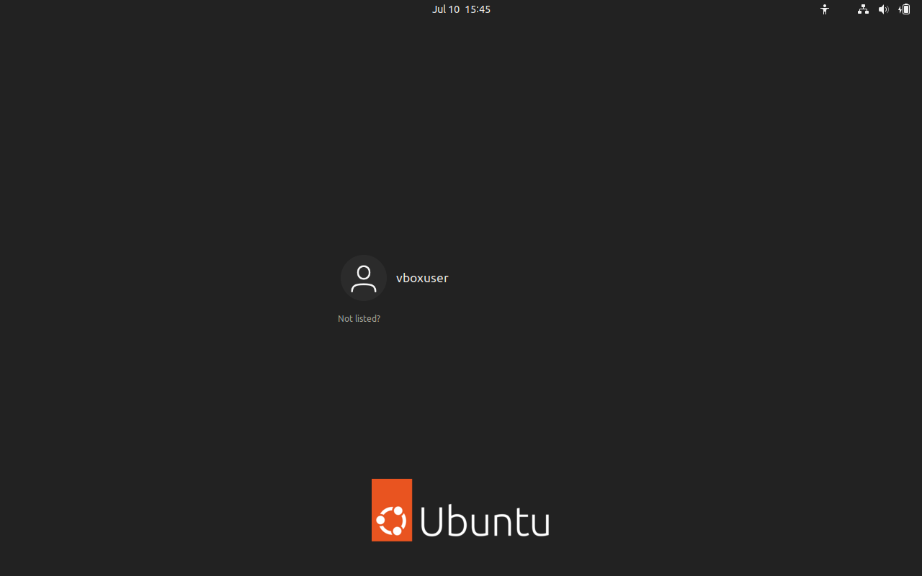

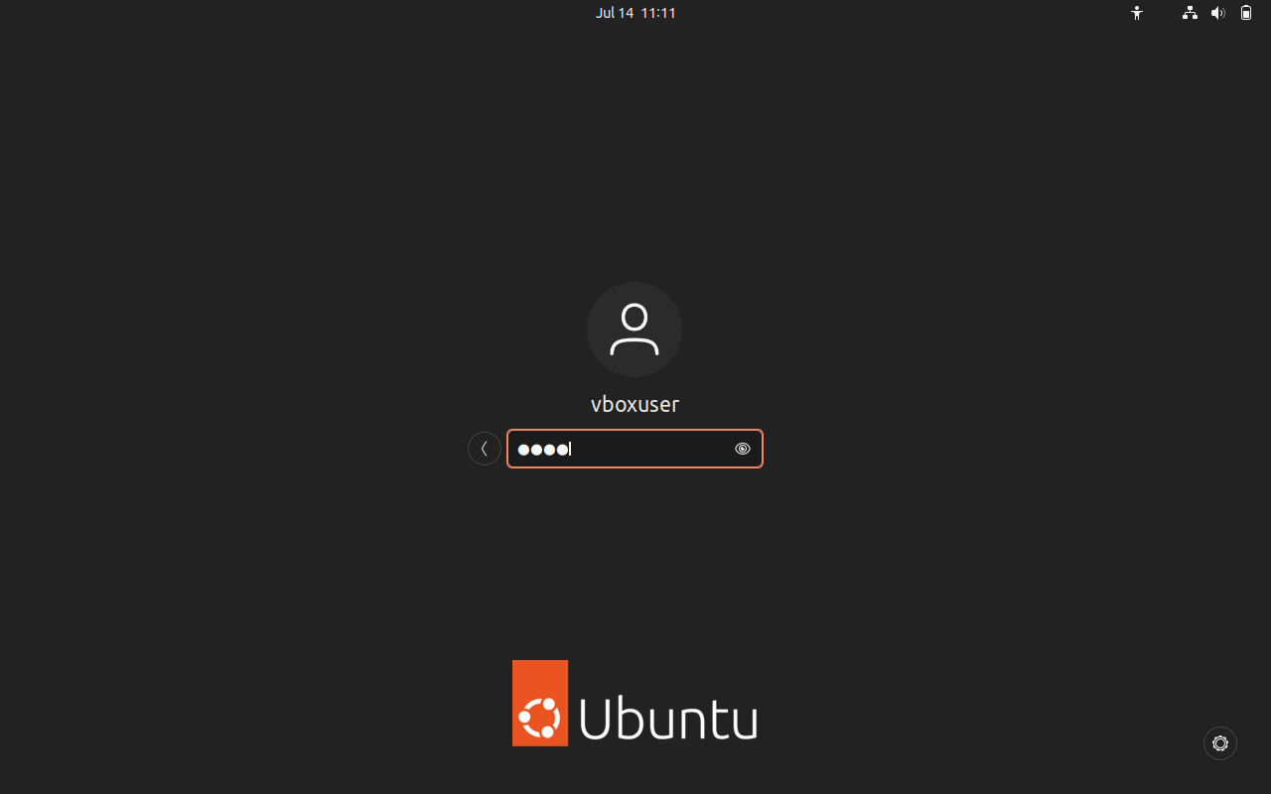

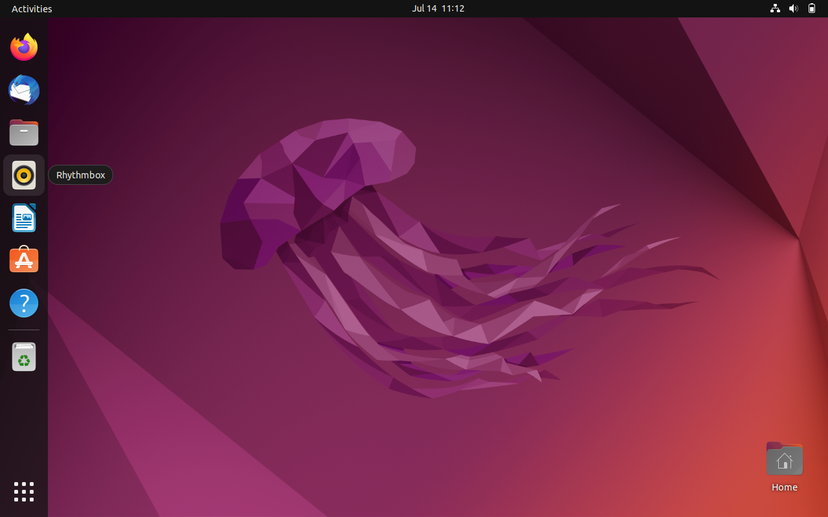

2.Set up Visual Studio code on Ubuntu VM

I downloaded the of visual studio code for Ubuntu

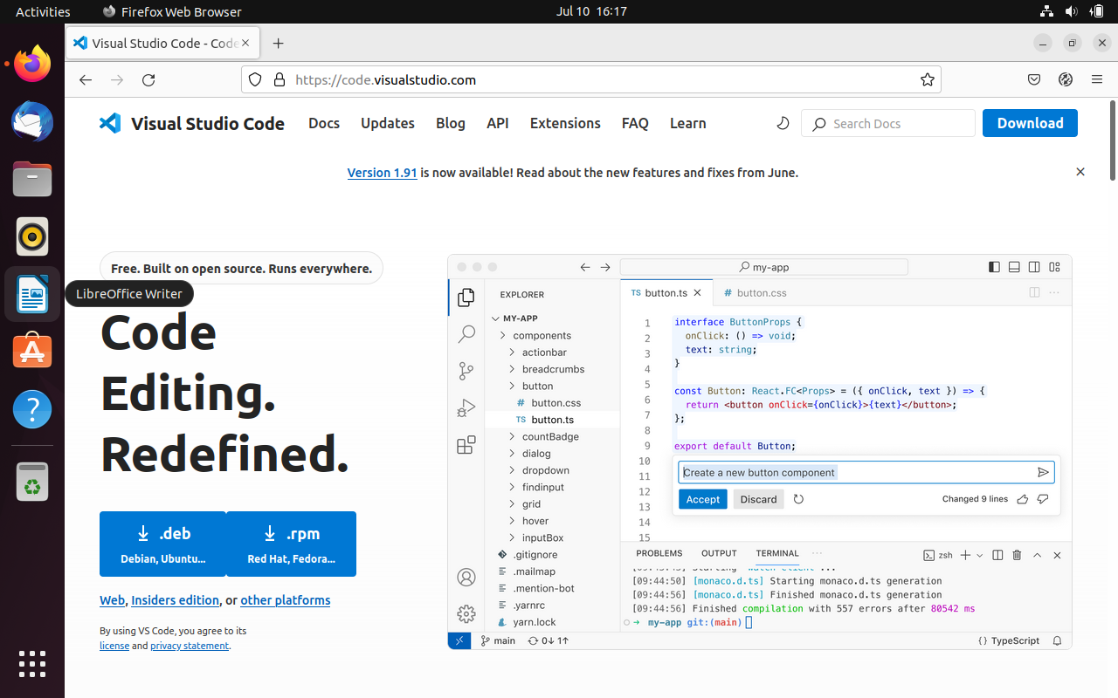

And installed it using following command:

Sudo dpkg –I code_1.91.0-1719861592_amd63.deb

Then enter the password for Ubuntu user it will step up visual studio code in ubuntu

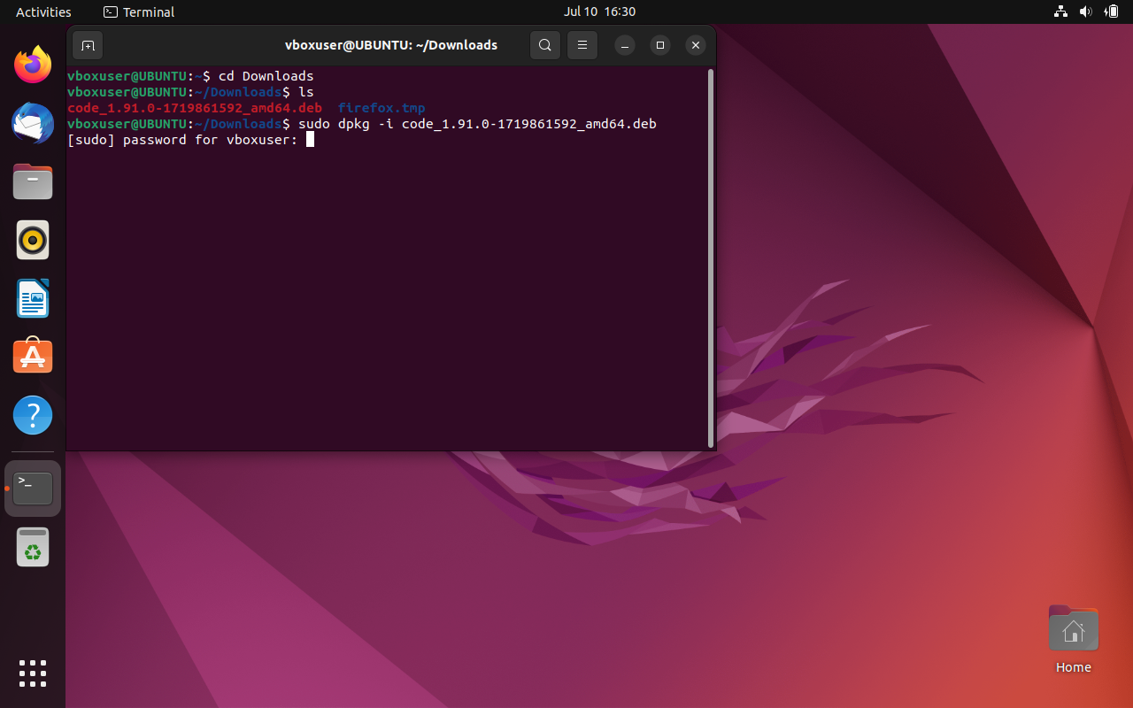

Then it appears in search

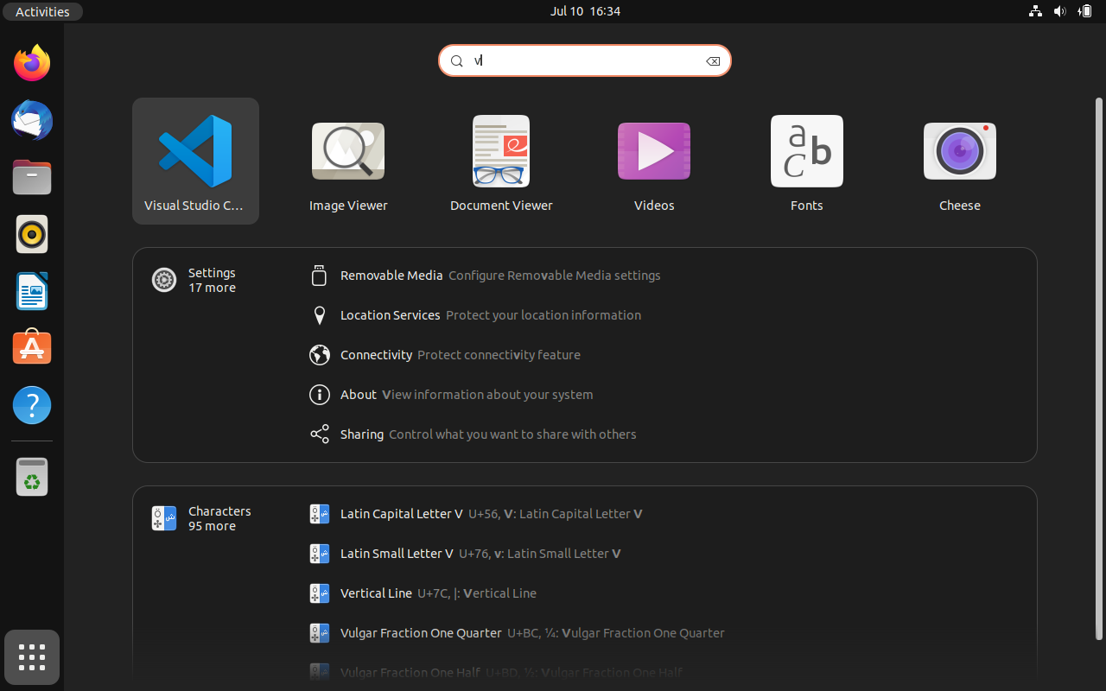

3.Set up Python:- for set up python first

sudo apt update

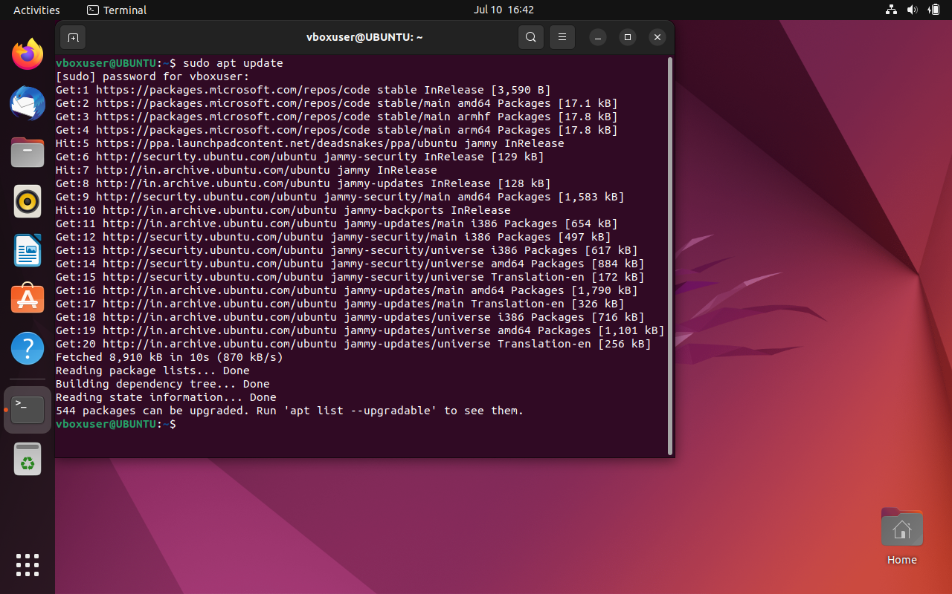

sudo apt install software-properties-common :-

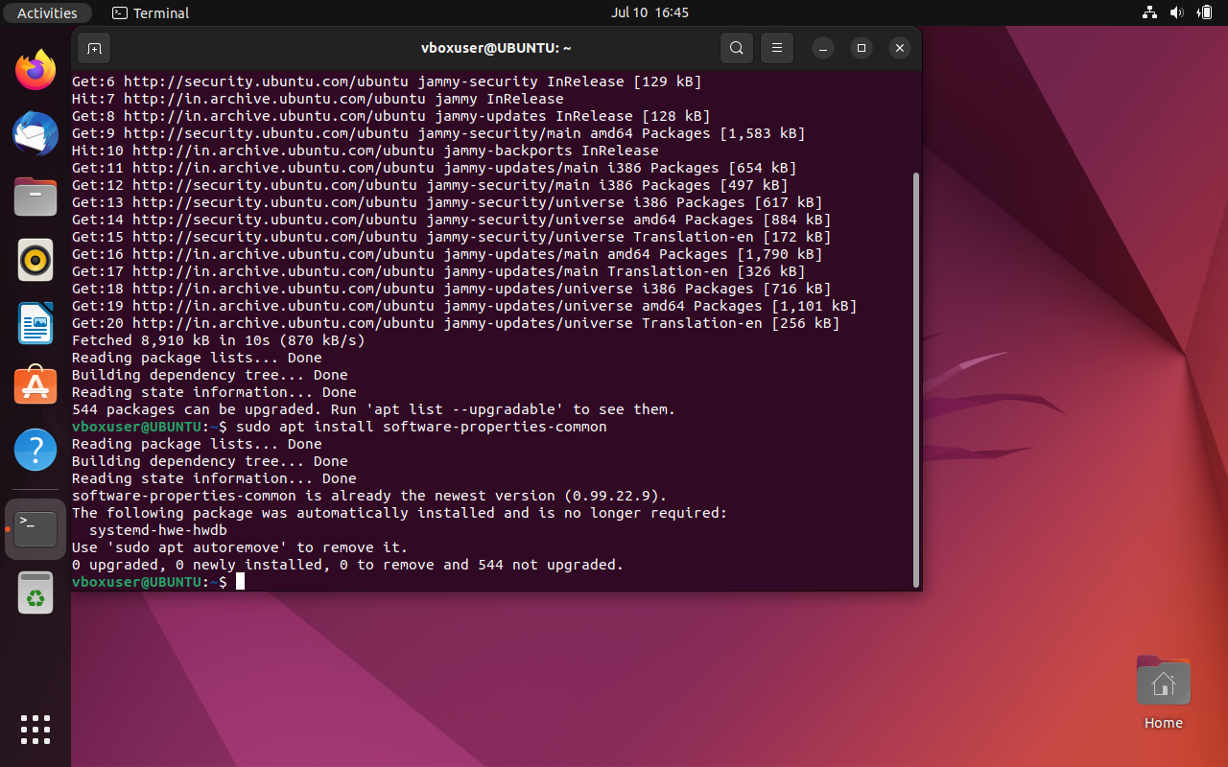

sudo add-apt-repository ppa:deadsnakes/ppa:-

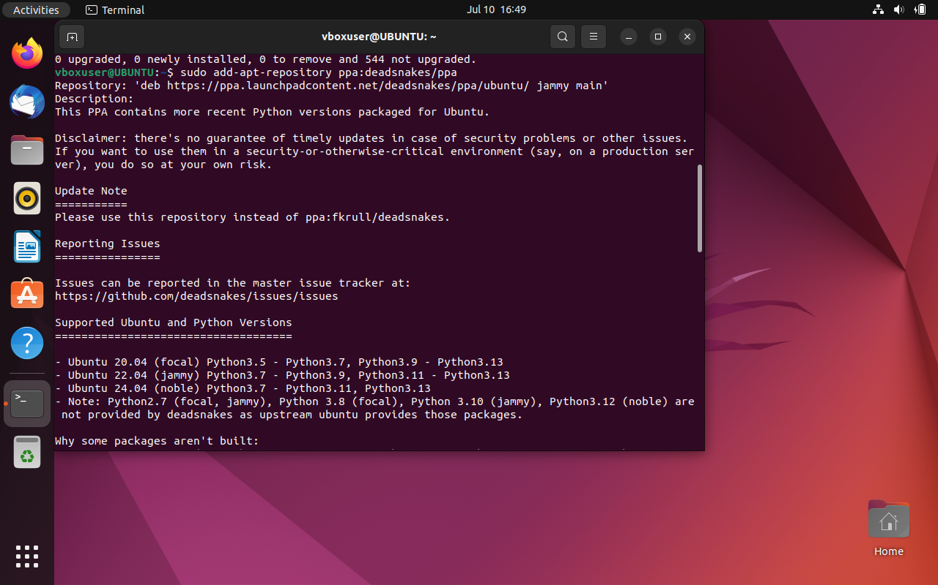

sudo apt install python3.10:-

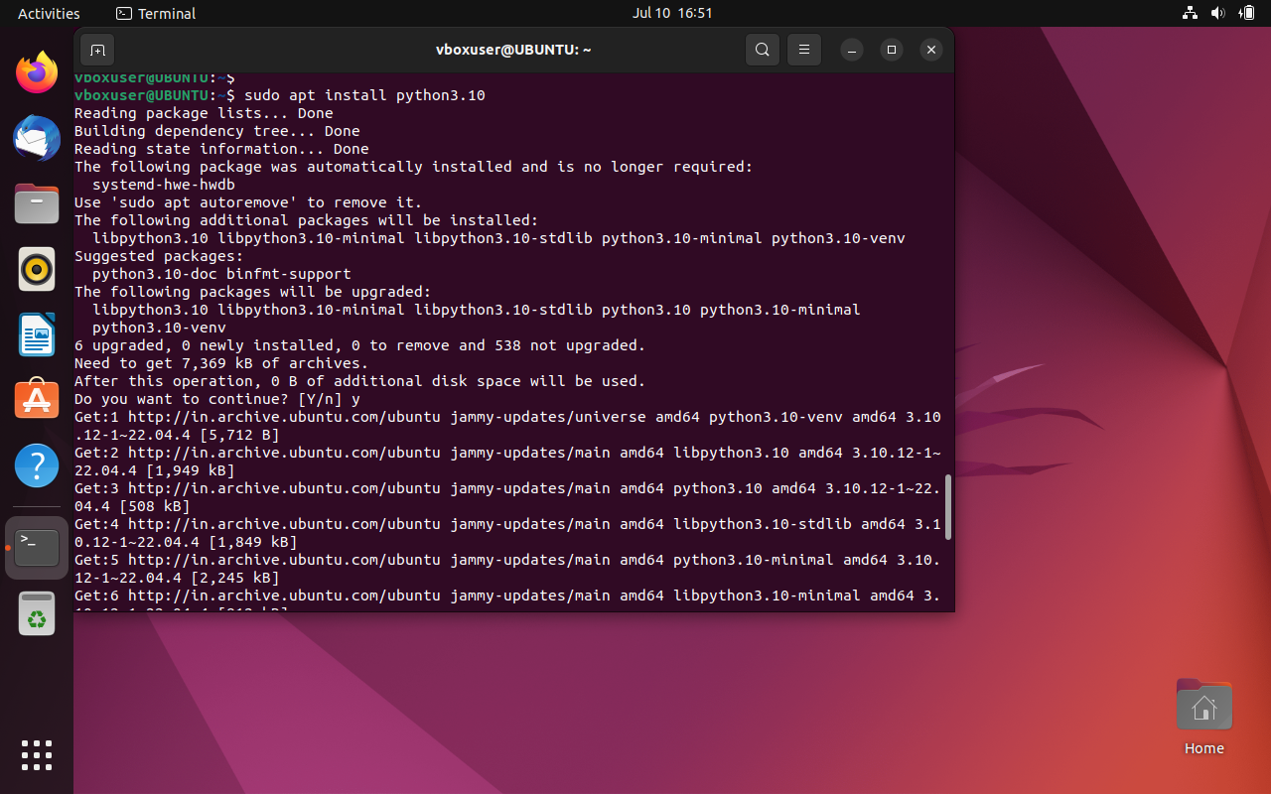

Verification of the installation was successful.Python3–version

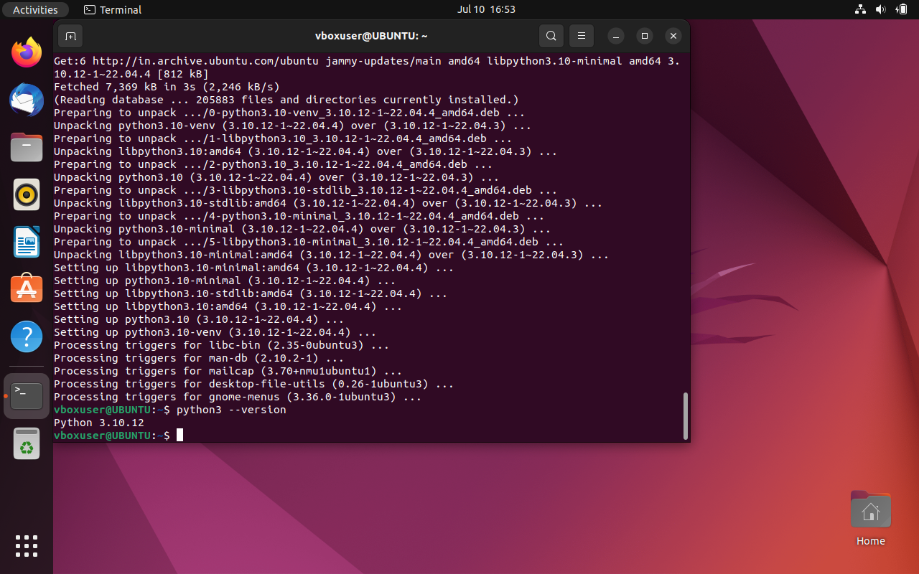

4.Clone this Github repository:

To clone repository open the vs code

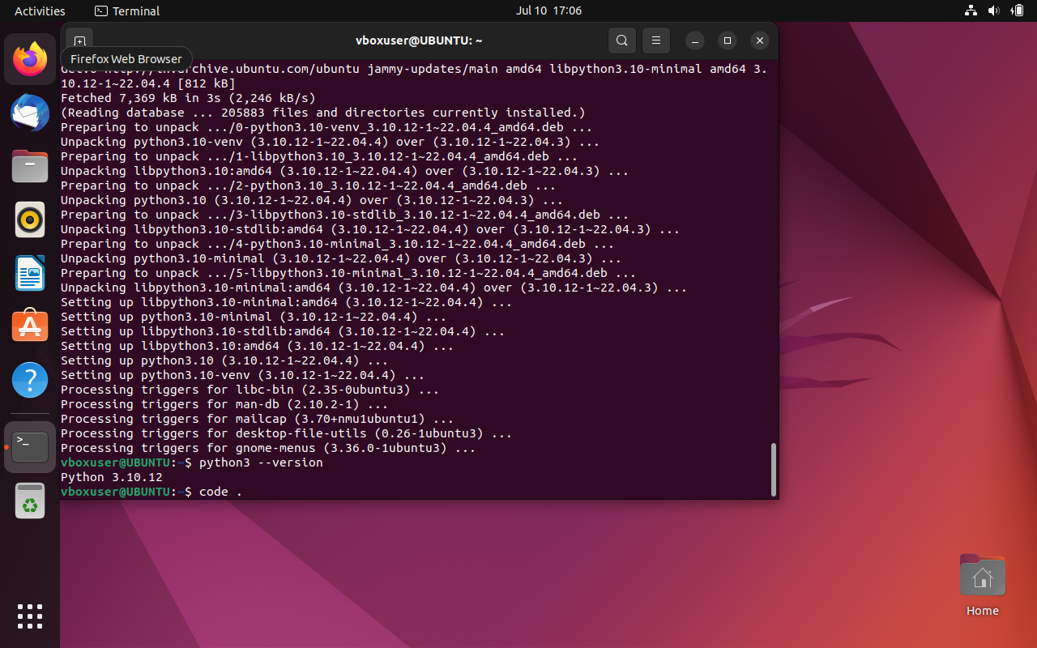

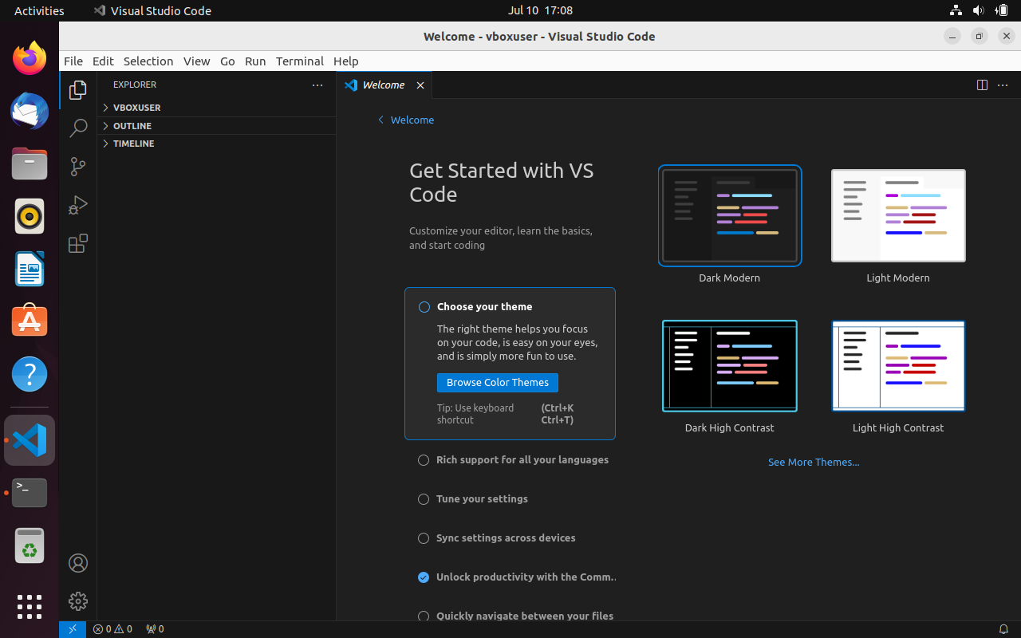

Then used ctrl+shift+p open command pallete then type Git:clone

Select that and type repositiory link as provided give the path to save the project folder Document/tests

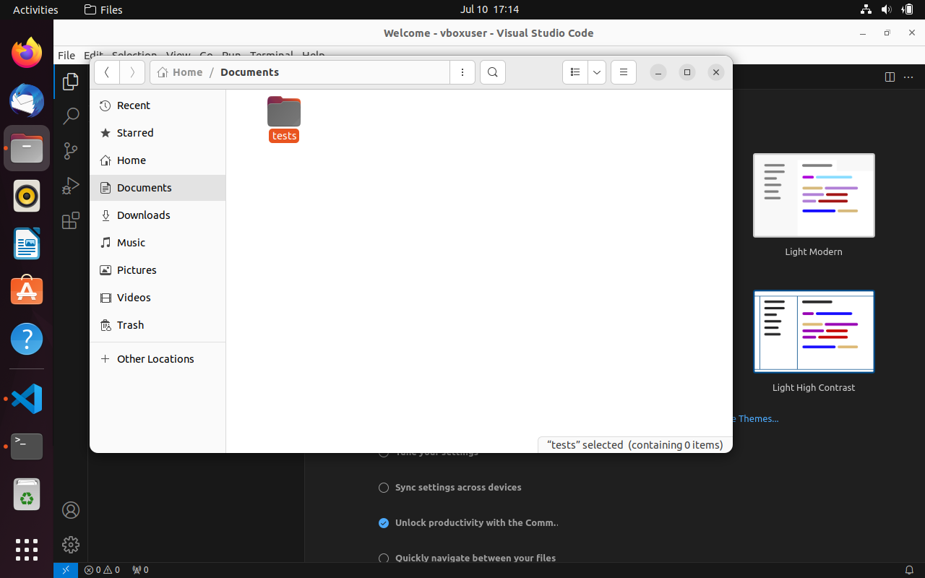

Open the repository in vs code

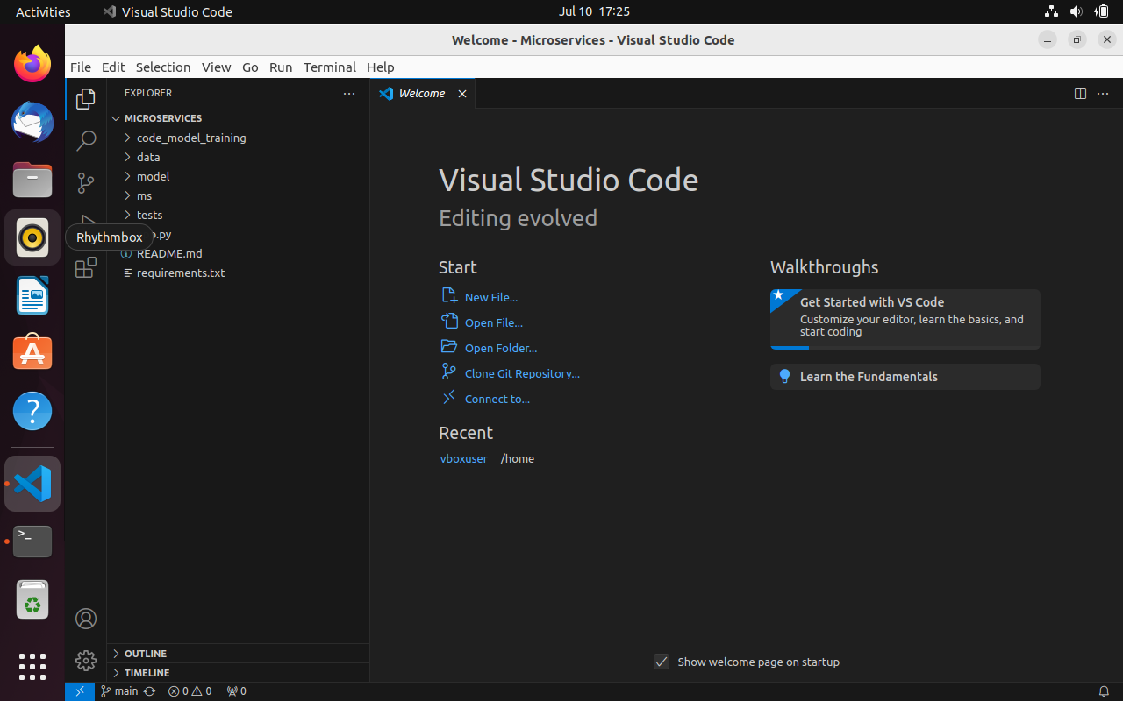

5.Create a Virtual Environment.:-

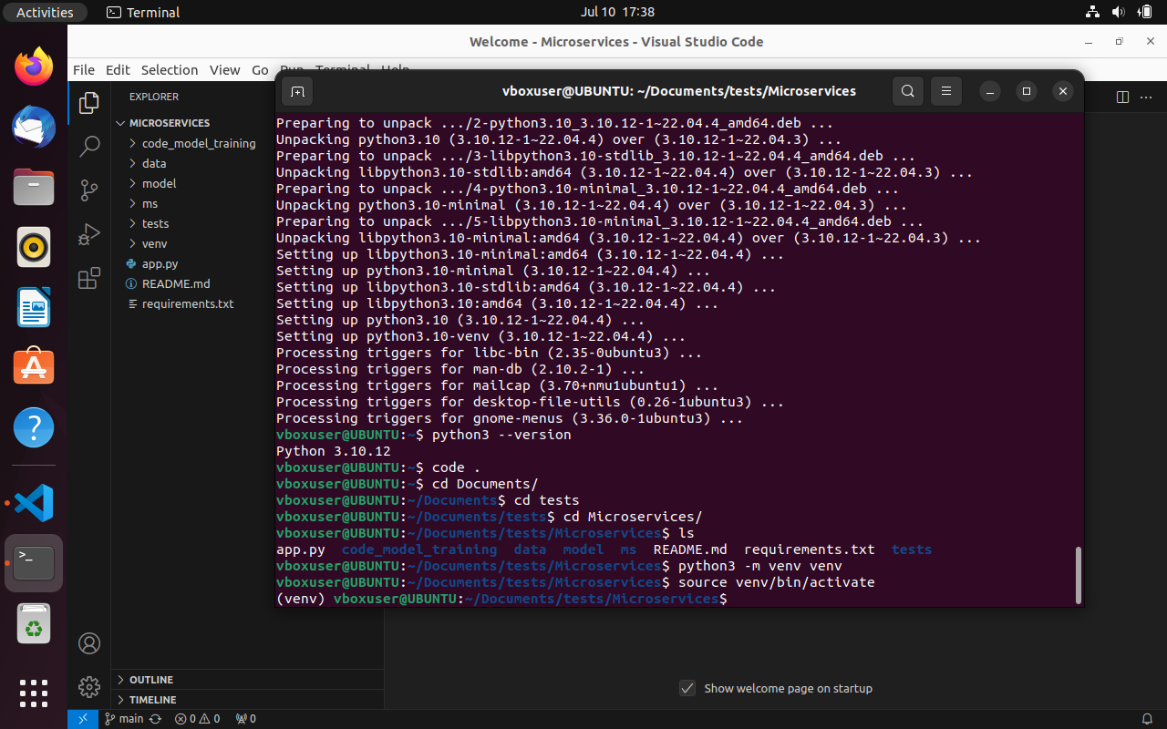

6.Install the dependencies from requirements.txt file.

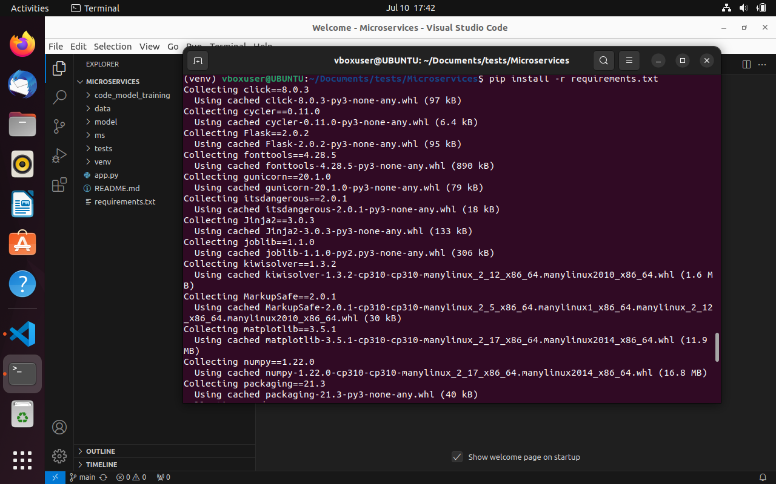

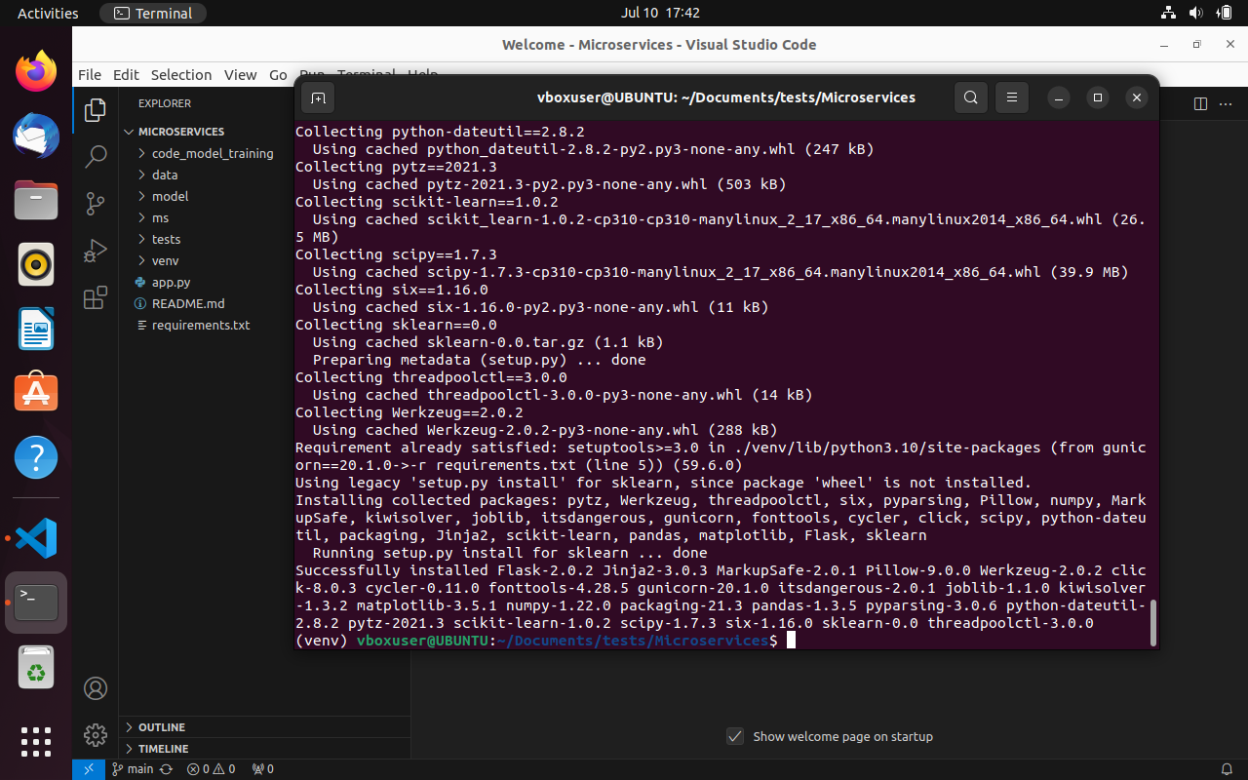

7.Train and save the model.

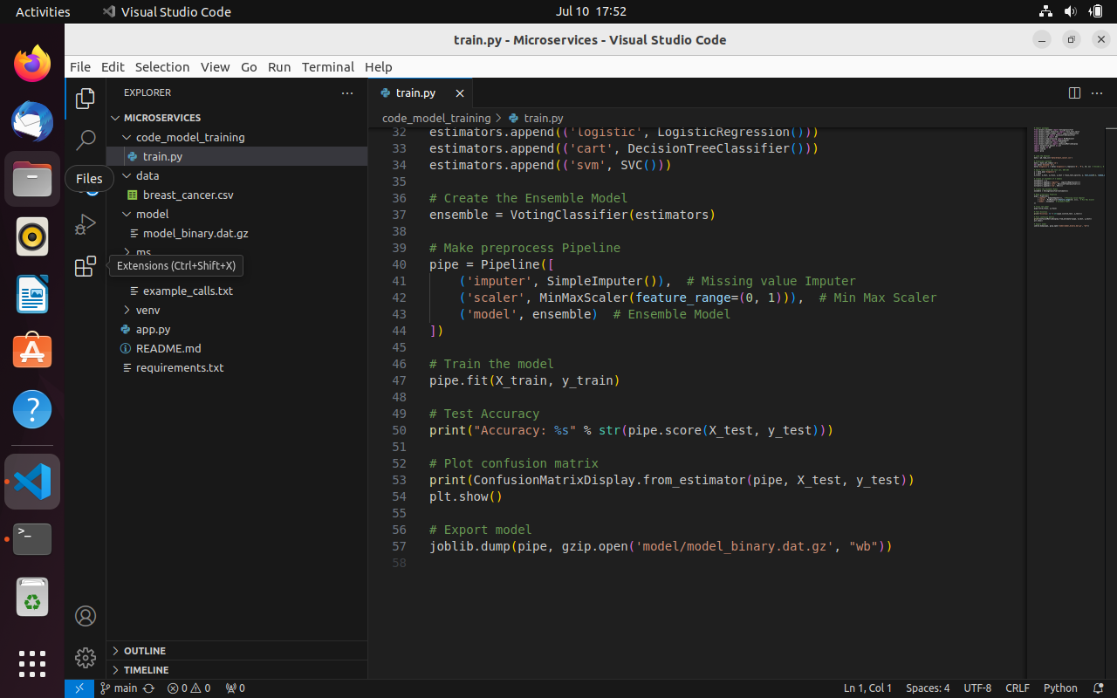



Run the train.py:-

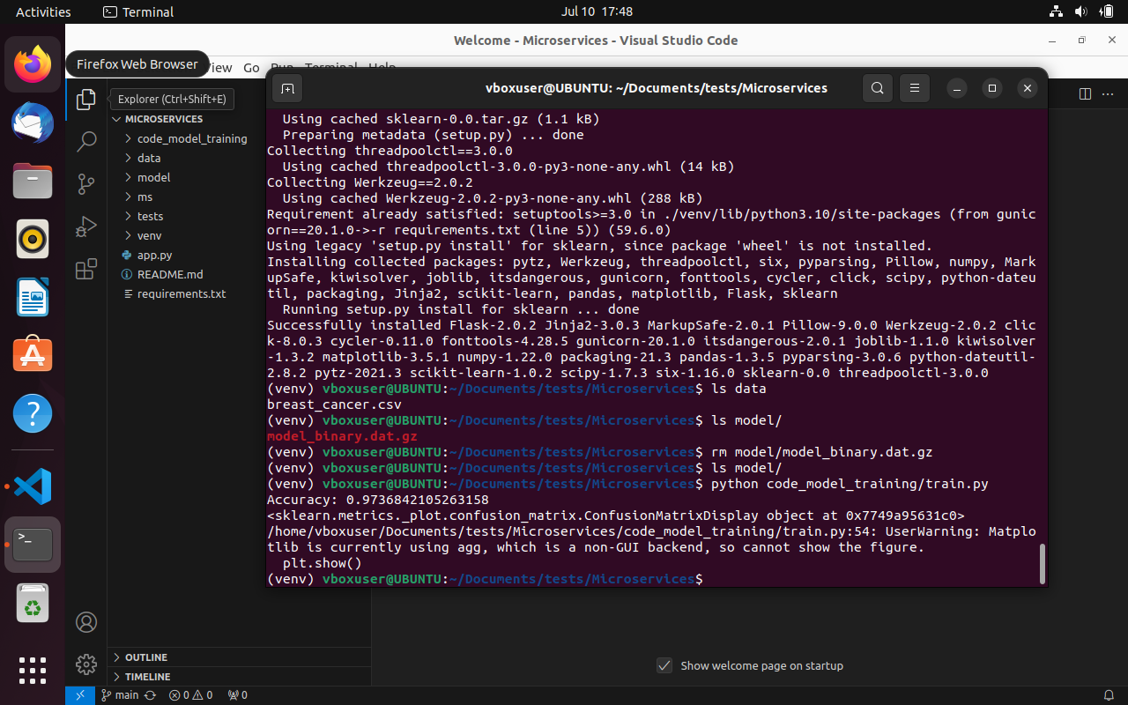

8.Test the Flask web application.

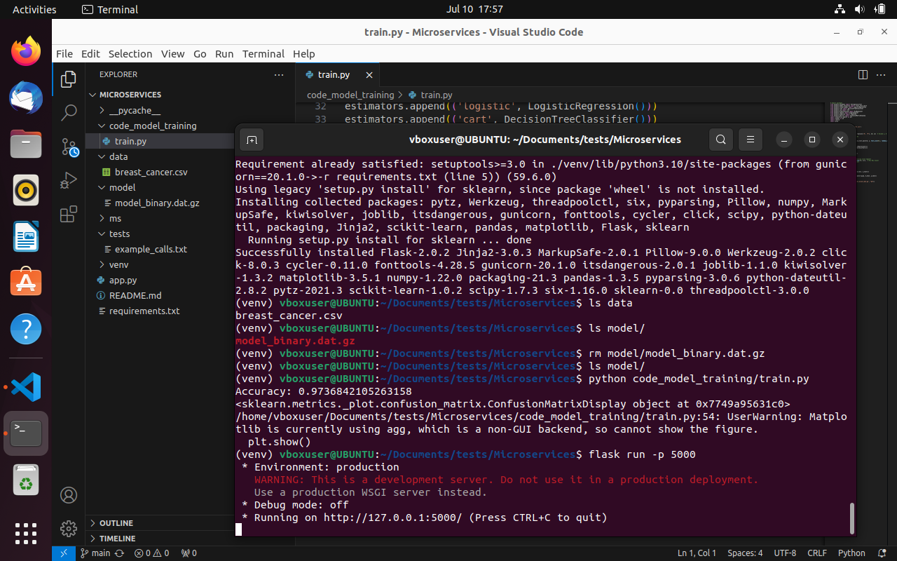

To test it is running open it in Mozilla firefox:

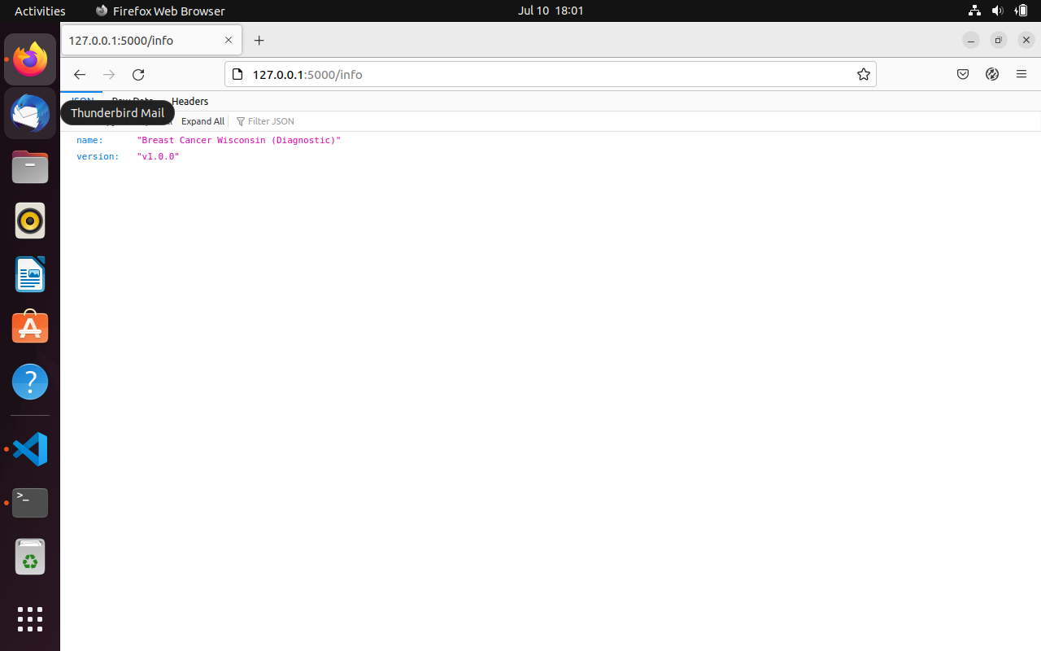

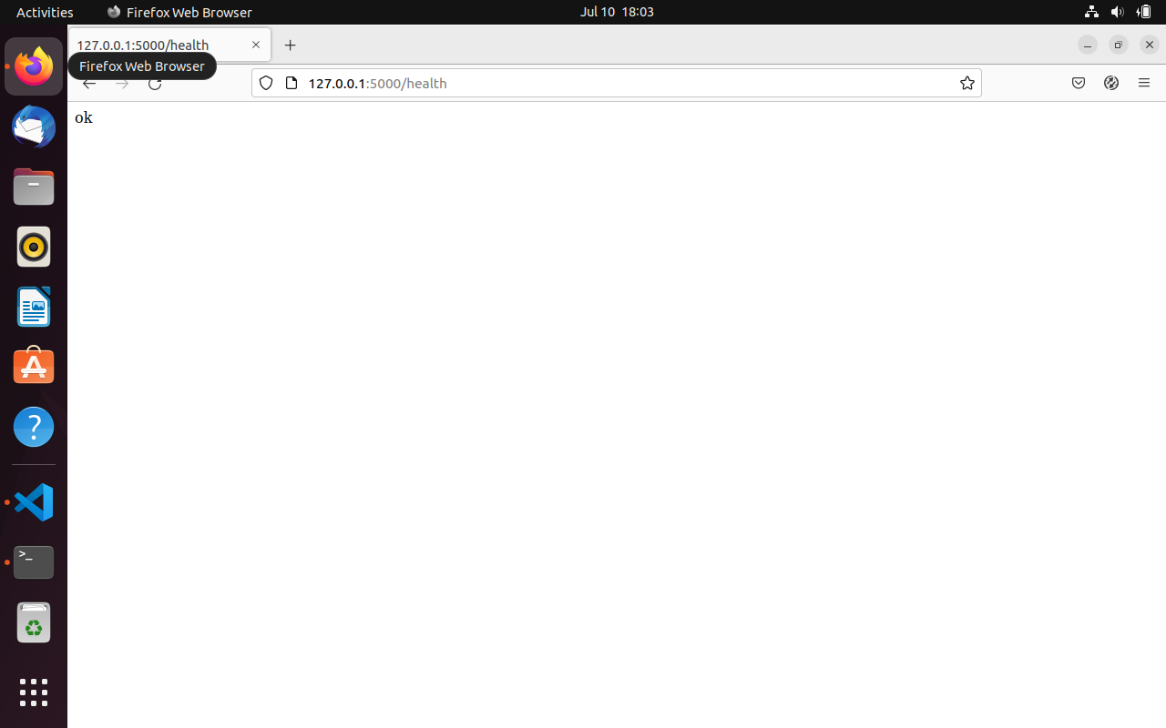

To check the post data I installed RESTer addon to give data and test the output for predict url:-

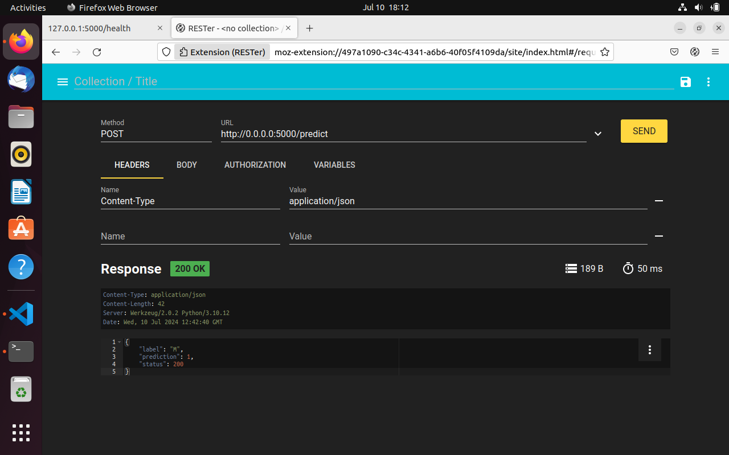

9.Test the application and make predictions using the example calls available in the folder/tests.

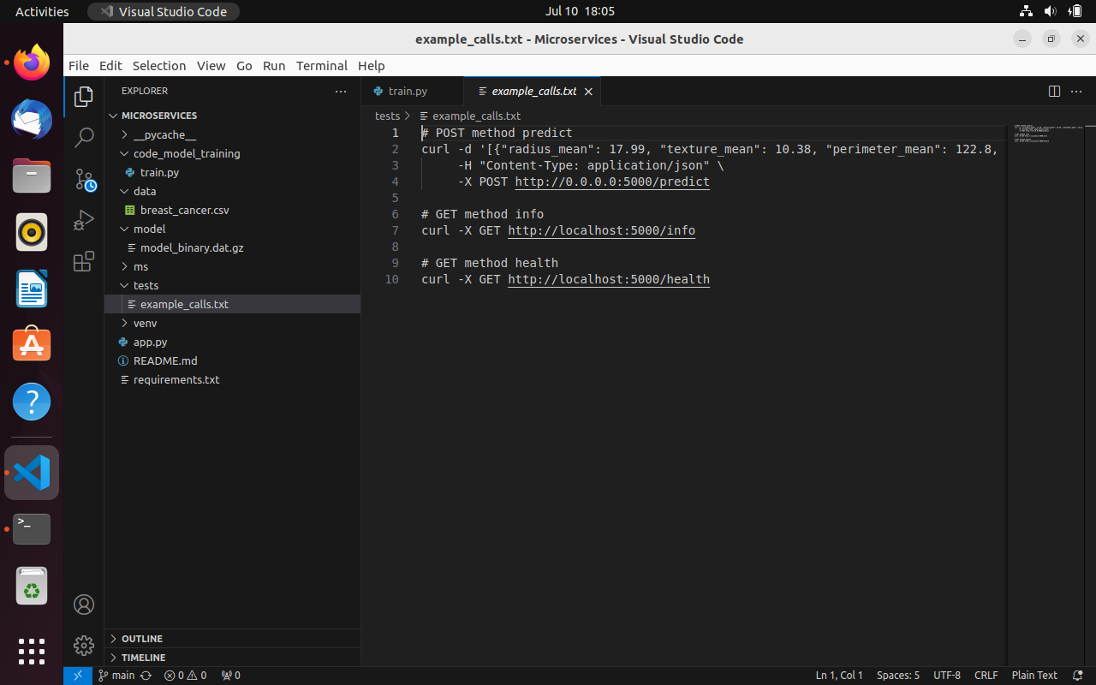

curl -X GET <http://localhost:5000/info>:

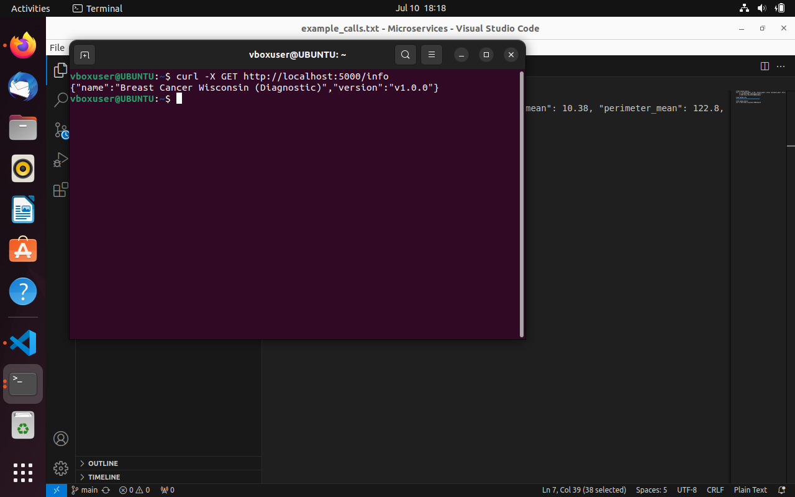

curl -X GET <http://localhost:5000/health>:

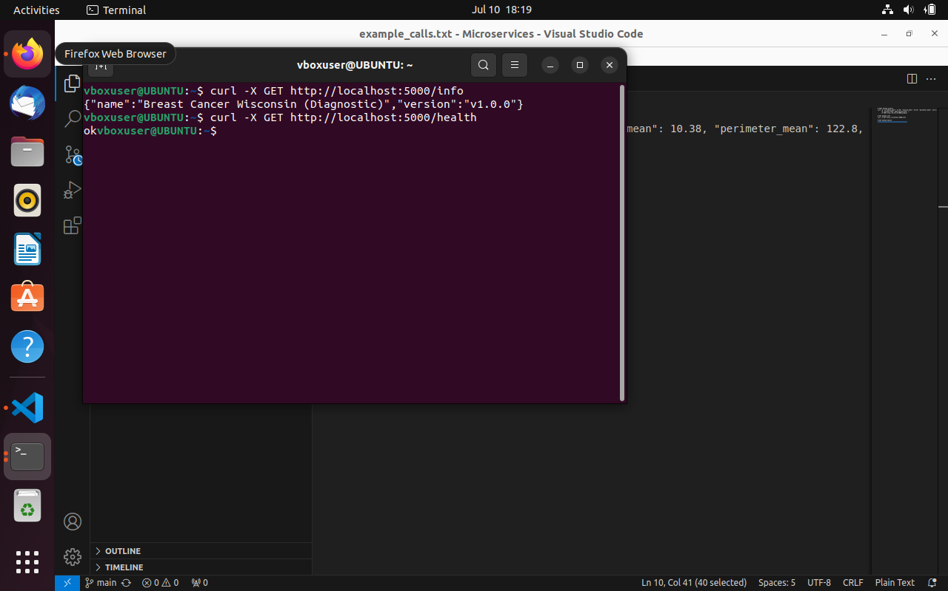

POST method predict:

curl -d '[{"radius_mean": 17.99, "texture_mean": 10.38, "perimeter_mean": 122.8, "area_mean":1001.0, "smoothness_mean": 0.1184, "compactness_mean": 0.2776, "concavity_mean": 0.3001,"concave points_mean": 0.1471, "symmetry_mean": 0.2419, "fractal_dimension_mean": 0.07871,"radius_se": 1.095, "texture_se": 0.9053, "perimeter_se": 8.589, "area_se": 153.4,"smoothness_se": 0.006399, "compactness_se": 0.04904, "concavity_se": 0.05373, "concavepoints_se": 0.01587, "symmetry_se": 0.03003, "fractal_dimension_se": 0.006193, "radius_worst":25.38, "texture_worst": 17.33, "perimeter_worst": 184.6, "area_worst": 2019.0,"smoothness_worst": 0.1622, "compactness_worst": 0.6656, "concavity_worst": 0.7119, "concavepoints_worst": 0.2654, "symmetry_worst": 0.4601, "fractal_dimension_worst": 0.1189}]' \-H "Content-Type: application/json" \-X POST <http://0.0.0.0:5000/predict>

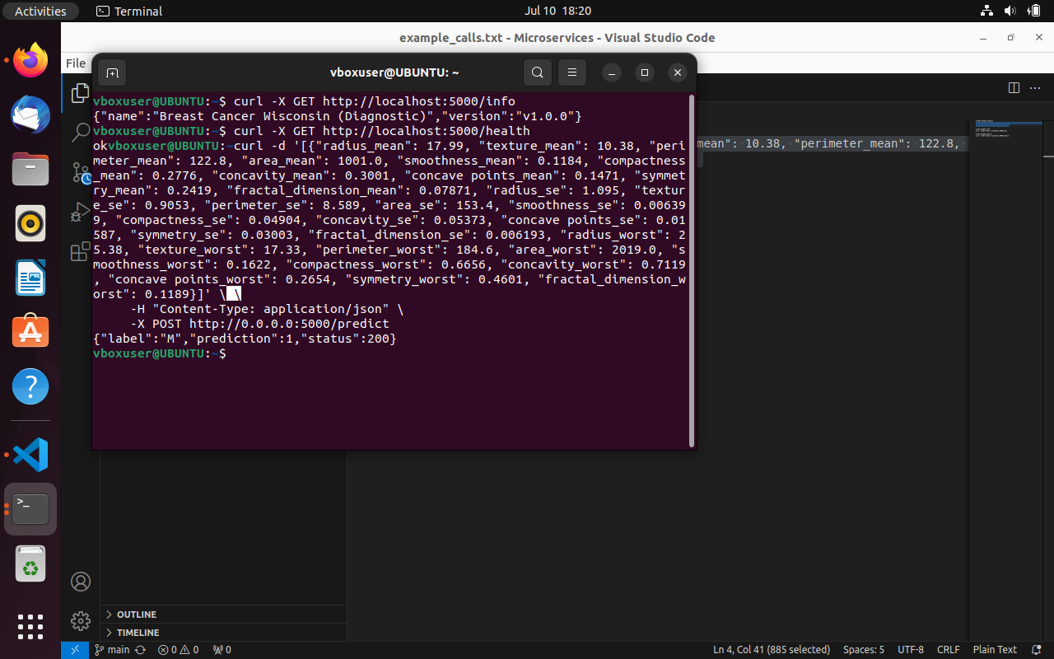

10.Create a docker image containing everything needed to run the application:-

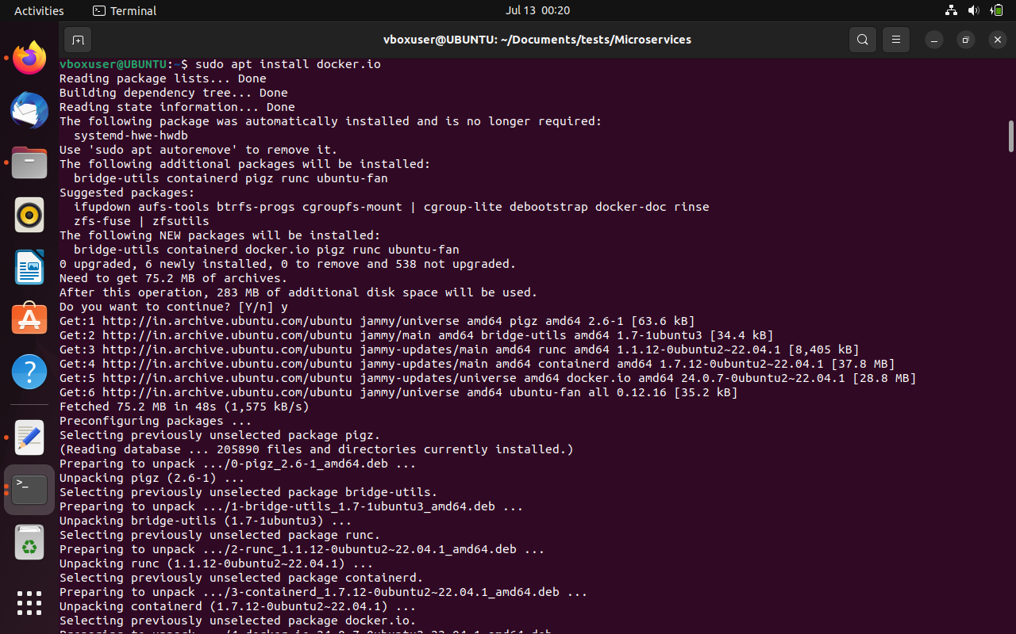

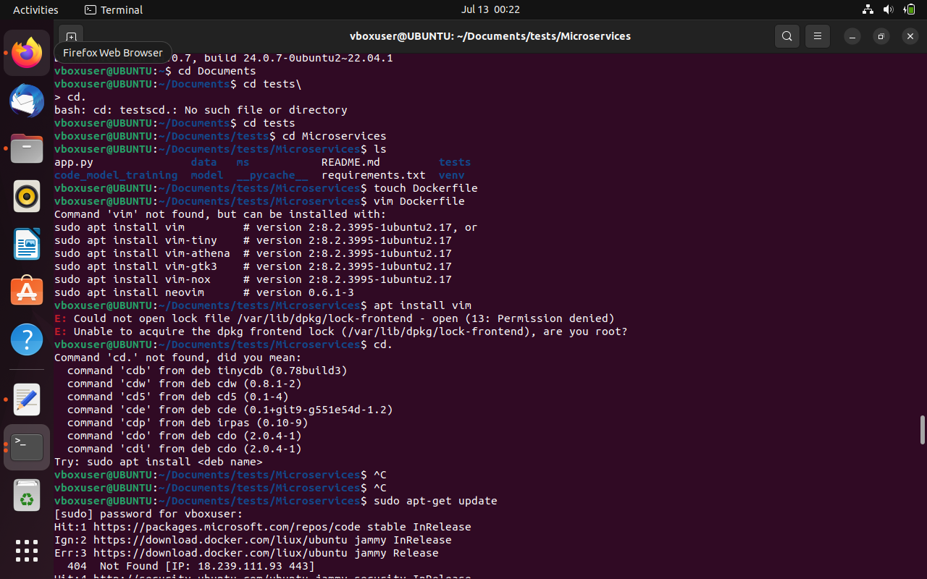

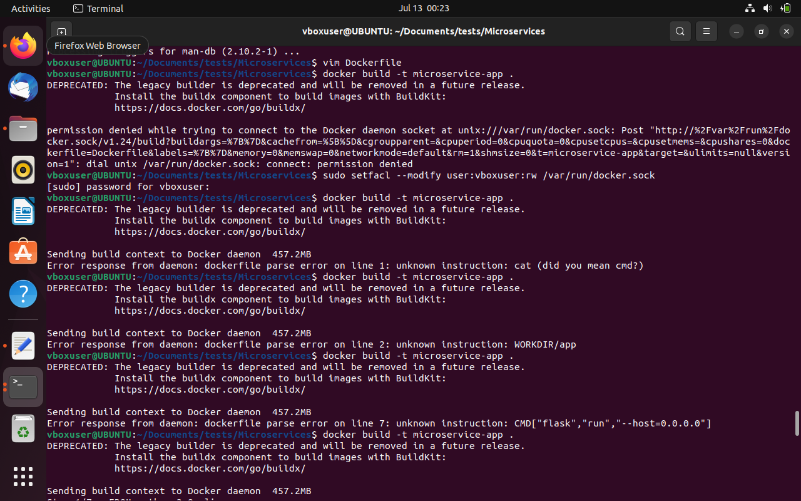

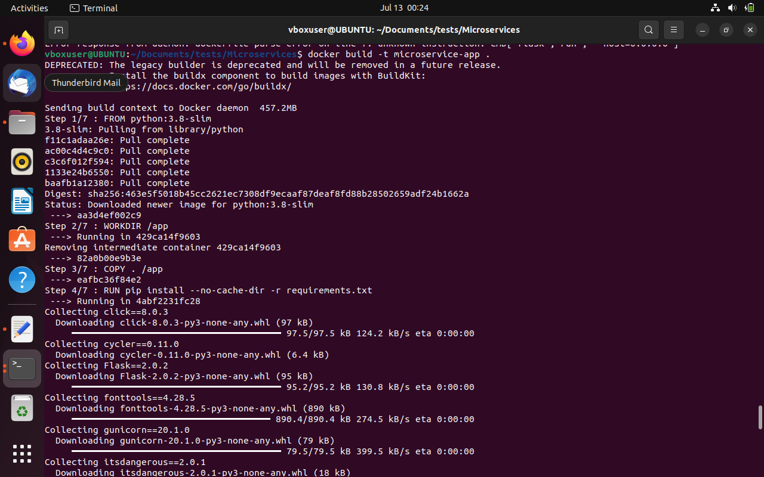

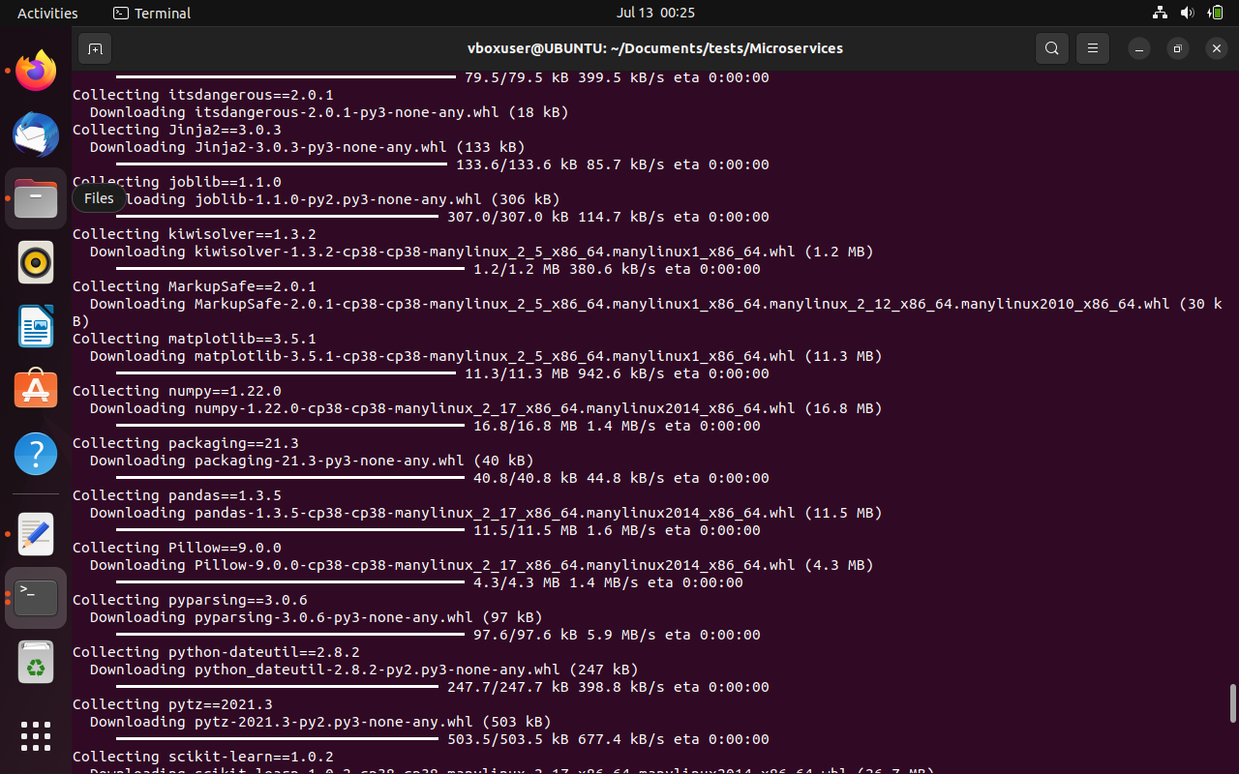

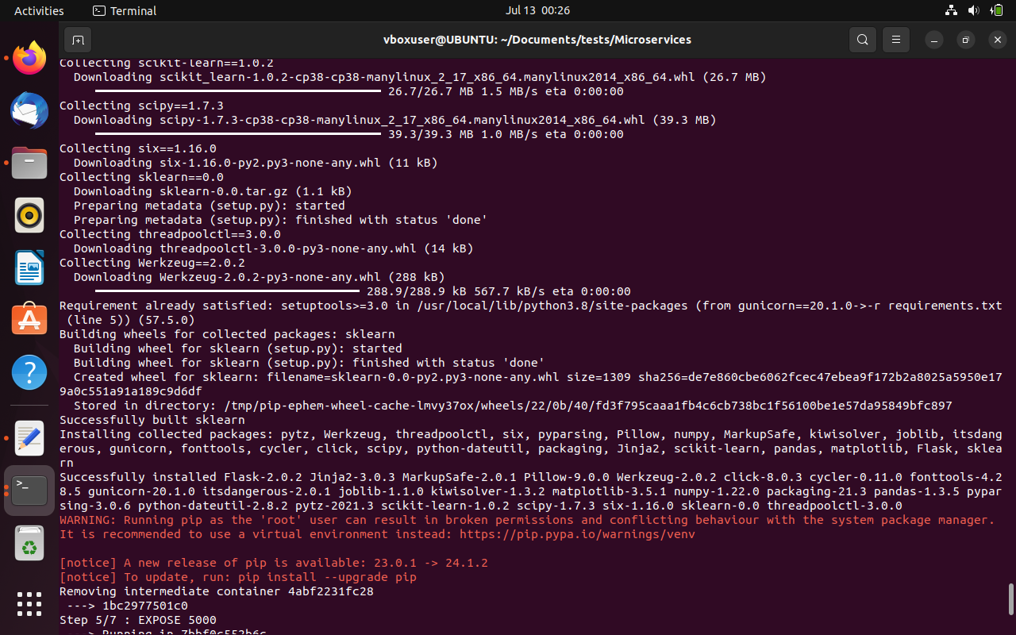

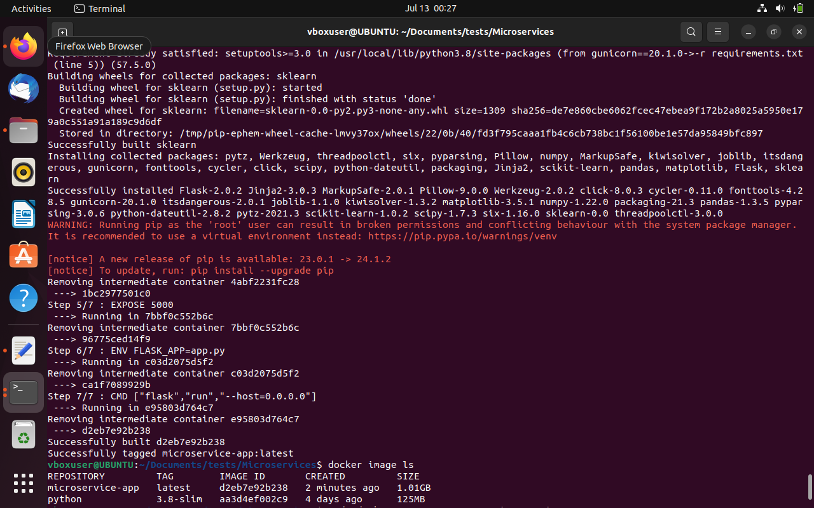

11.Run the containerized application as a prediction service and test it locally by passing some example calls and get the prediction.

